AI Adoption Mastermind

Slide 1 - Ben Hawksworth

How AI will change your life and business if you learn how to use it

Slide 2 - Host introduction

My name is Ben Hawksworth.
Founder at The Coach Consultant.
Founder at the Walk and Talk Men's Club non-profit organisation.
Husband, girl, dad.
ADHD and ASD, probably A, B, fucking C as well
I like to climb mountains.

Slide 3 - My experience with AI in the last 12 months

Adopted heavily to it before most other people
It was a risk, and it was quite slow at first.
Even without the benefits that I see now, I increased my profit margin by 28%.
Easily launched a hard copy book.
Rebuilt my entire programme.

Slide 4 - Current Situation With AI

Just bought my dream home.
Easily buy investment properties with extra profits.
I hired my own internal AI development and consulting team.
Built a full administration and executive assistant team.
Fastest that we've ever scaled.
With better profits

Slide 5 - What I'm gonna teach today

I'm not going to blow your head off with demos.
I'm not going to throw shitloads of different tools at you.
There might be parts where it seems like I'm teaching you to suck eggs.
I want to teach you how to maximise AI.
People think it's all about the system.
It's not. It's about human intuition.

Slide 6 - What energy does it take to create an adult with intelligence?

How much food in 21 years?
How much water in 21 years?
How much education in 21 years?
How much support in 21 years?
Or, in my case, how many drinks, drugs, and bad mistakes in 21 years?

Slide 7 - Now let's look at what it takes to train an AI system.

Literally a few hours.
And it will be better than that 21-year-old.
And it will be better than you right now.
And it will be better than us forever

Slide 8 - If you fight against a revolution, you are fucked.

The Industrial Revolution from 1760 to 1914 - What do you do here? Keep driving a horse and cart?

The digital revolution from 1950 to 2010 onwards - What do you do here? Keep sending letters and faxing things.

The AI digital revolution from 2002, 2026, heavily from 2010 onwards - What do you do here? It's the same as the other situations.

Slide 9 - And this shit ain't gonna be slowing down any time soon.

Overall, the AI market is growing at a 25 to 30% annual compound growth rate.

Generative AI is going upwards of 40% annual compound growth rate.

Slide 10 - Now I want to talk about how impossible is now possible.

If you have a vision for it, you can achieve it.
If you have an idea, you can build it.
Maximising AI stems from human intuition first.

Slide 11 - Step 1: What do you see here? (3 people)

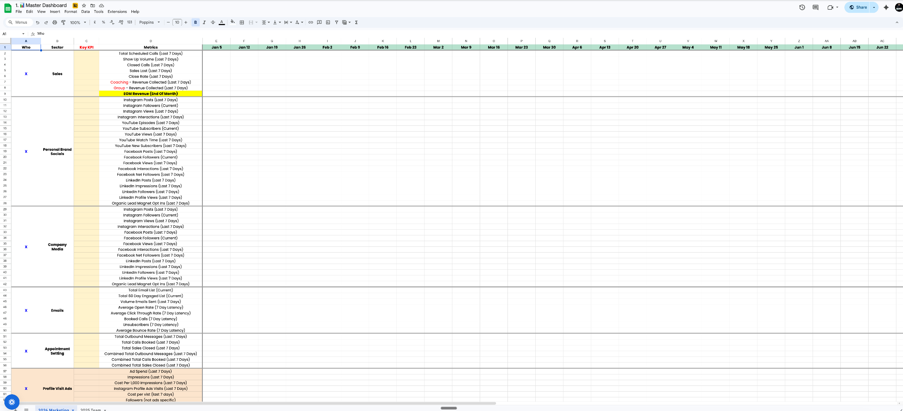

Slide 12 - This is what I see

Phase one: Visual Interactive Dashboard
Phase two: API and MCP integrations pull in live data.
Phase three: scraping all competitors' accounts and creatives
Phase four: building intelligence dashboards that combines phase 2 and phase 3
Phase five: agentic agents who pull through assets into production and scheduling.

Slide 13 - Core mission: remove any form of guesswork associated with
- Instagram
- YouTube
- LinkedIn
- TikTok
- Facebook
- email marketing
- DMs
- meta ads
- anything that can be pulled from an API

Slide 14 - Step 2: Stop being a platform slut.

Select one platform and then own it.
I use Claude Chat
I use Claude Projects.
I use Claude Cowork.
I use Claude Code.

I will touch on other platforms here and there and different connectors, but I'll try and focus all my time and attention into one place.

Slide 15 - Step 3: Don't prompt; communicate.

Download Wispr to your computer and your phone.
https://wisprflow.ai/
It transcribes, punctuates, and formats a lot better than anything that I've used.
Speak to AI like you're speaking to a normal person.
Articulate yourself clearly. Be descriptive, be creative. Ask leading questions.

Slide 16 - Prompting gives you a framework, and yes, it's highly efficient.

I've got over 400 proprietary Go prompts that I just give to clients as an asset.
That removes any manual workload that they ever need inside the business.
But that's not where the real power of AI lies.
It lies in your human intuition and intelligence.

Slide 17 - Step 4: Understanding the foundations.

AI instruction = How it should behave.
AI knowledge = What it knows.
AI prompt or communication = What you ask right now

Slide 18 - Do not suddenly think that you need to become a fucking technician.

Describe the actual instruction that you want and ask AI to give it to you.
Ask AI what knowledge base you need.
Ask AI to give you a prompt to generate that knowledge.
Then ask AI to give you the go prompt.
Or just communicate with it with Wispr, which is what I do. I barely ever prompt.

Slide 19 - The skills bank you need for maximising AI

Cognitive and thinking skills.
Communication skills.
Self-awareness skills.
Leadership and decision-making skills
Creative skills.
Execution skills.

Slide 20 - Disclaimer.

It's the same shit that you use to get to where you are now in business.
The single only difference is you're not doing it manually.
Instead of "I need to do this."
Focus on how can AI do this for me?

Slide 21 - Problematic and thinking skills.

Pattern recognition - Make a list of every repetitive and manual task that you're currently doing in your week and days.

Systems thinking - How can you combine multi-layered step-by-step processes into one single project space?

First principle thinking - Go back to the absolute basics of what you are trying to achieve in that specific area and build it from scratch with AI.

Vision clarity - If you can't describe what you want, then you don't know what you want, and AI shouldn't be doing it for you. Start there first.

Critical evaluation - Read, check, iterate. Don't just max process.

Slide 22 - Communication skills.

Articulation - This is why I use Wispr for precision, depth, and as much articulation and information as possible to format the output that I want.

Contextual framing - Making sure AI has enough information and knowledge base or in what you are asking so it gives you the right type of output

Iterative dialogue - Treat it like a conversation and not a transaction. This is probably the most important skill.

Slide 23 - Self Awareness Skills

Knowing your genius zones - You can't check something's actually right if you don't actually fucking know it yourself.

Be honest with your bottlenecks - Eager gets in the way of delegation, especially when it comes to AI. You think it can't do it as well as you. It Can.

Emotional regulation - Frustration with AI will kill momentum. If you ain't got patience, don't even fucking attempt it.

Slide 24 - Leadership and decision-making skills.

Prioritisation - You can 100% do a hundred things at once, but don't do that. Focus on executing one high-level thing at a time.

Judgement - AI is going to give you unlimited options, but it's still you who has to make the call.

Taste - Making sure you're actually reading everything on the output so you can formulate the next reiterations

Ownership - Treating your AI outputs as an actual responsibility, not just to be lazy.

Slide 25 - Creative skills.

Imagination - This is a vision for me.You need to be able to picture it yourself first. Then it's pretty easy to build it with AI.

Willingness to experiment - You might go through four or five different variations until you get to the point of having it right for what you want.

Slide 26 - Where can AI actually help your business?

https://benhawkcode.github.io/Claude-Projects-Guide/

Slide 27 - Content and marketing.

Content strategy and calendar.
Blog on long-form content.
Email marketing and sequences.
Lead magnets and opt-in content

Slide 28 - Social media.

Instagram content creator
LinkedIn content.
YouTube content unscripted
Content repurposing engines

Slide 29 - Sales and lead generation.

Sales page on London page copy
Proposal on pitch writers
DM and Outreach Sequencer
Webinar and workshop planner

Slide 30 - Client fulfilment and delivery

Client onboarding assistance.
Coaching session prep and notes
Client reporting and results
Course and programme content.

Slide 31 - Operations and Business Management

SOP and process documentation
KPIs and business report
Team Communication and Management
Finance and invoicing.

Slide 32 - Strategy and growth.

Business strategy and planning.
Brand positioning.
Partnerships
Customer Research and Insights

Slide 33 - Admin and organisation.

Email and Communication Manager
Meeting an event coordinator.
Legal and compliance drafts.
Personal productivity and planning

Slide 34 - FYI, that's just one platform on one section on Claude projects.

And I have that built as a step-by-step copy and paste SOP for people.

Slide 35 - Don't get distracted by shiny objects with AI.

Will this make me move faster?
Will this make me get more done?
Will this provide me with more insight?
Will this remove guesswork?

That is the only four questions I ask when I build anything with AI.

Slide 36 - AI adoption execution (step 1)

Step one: Audit your entire business for one week.
Log every repetitive task.
Log every manual task.
Log every time-consuming task

Not what you think.
What you actually do.
This is your delegation list.

Slide 37 - AI adoption execution (step two)

Pick one problem and solve it completely.
Don't try to automate your entire business at once.
Pick the single most painful or time-consuming thing on the list.
Build an AI solution for it.
Then move on to the next one.

Slide 38 - AI Adoption Execution (step three)

Build the foundation is not the future.
Focus on designing the instruction first.
Then build out the knowledge base.
Then communicate and test.

This is the difference between using AI and owning AI.

Slide 38 - AI Adoption Execution (step four)

Delegate and remove yourself.
Once you've checked a few outputs and it's good, it'll simply just repeat that.
If you've got a team member and you're happy with it, give it to them.

Slide 39 - AI adoption execution (step five)

Compound and expand.
Every system, project space, or tool that you create
Make the next one faster. The knowledge base stacks.
Every prompt you refine gets sharper.
Once you've nailed the foundations and basics first

Slide 40 - What this actually buys you

Not just profit.
Not just time.
The thing nobody speaks about.

You get your head space back.
You get your energy back.
You get your startup founder energy back.

Slide 41 - The only real barrier that you've got

It's not the tools.
It's not the tech.
It's not the budget.

It's the decision to actually start and adopt properly.
It's the decision to have the patients see it through.

Slide 42 - The best time to start was a year ago. The second best time is today.

Slide 42 - Thank you for listening.

Any questions?

